Final Project Report Template

Smartphone Usage, Digital Addiction & Well-Being Analytics
1. Introduction
1.1. Project overviews
The Smartphone Usage & Digital Addiction – Well-being Analysis project examines how smartphone usage habits are associated with digital addiction and user well-being. The dataset contains 7,500 user records with information about screen time, social media, gaming, sleep, stress, notifications, app opens, and demographics. The analysis is performed using MySQL and Microsoft Power BI. SQL is used for data preparation and analysis, while Power BI is used to create interactive reports and dashboards.
1.2. Objectives
- To analyze smartphone usage and digital addiction patterns.
- To identify factors associated with addiction levels.
- To study the relationship between screen time, sleep, stress, and usage behavior.
- To visualize important insights using Power BI.
- To support better awareness of digital well-being.

2. Project Initialization and Planning Phase
2.1. Define Problem Statement
Excessive smartphone usage can affect users' daily activities, sleep, academic/work performance, and overall digital well-being. The objective of this project is to analyze smartphone usage data and identify patterns associated with digital addiction. Out of 7,500 users, 5,308 users (70.77%) are classified as addicted. Therefore, the analysis focuses on identifying usage patterns associated with addiction, including screen time, weekend usage, social media, gaming, notifications, app openings, sleep, stress, and demographic characteristics.
2.2. Project Proposal (Proposed Solution)
The proposed solution is to develop a data analytics and visualization system using MySQL and Power BI.
Proposed Process:
Raw CSV Data → Data Cleaning → SQL Analysis → Data Preparation → Power BI → Dashboard → Insights
The Power BI dashboard provides users with interactive filters and visualizations to analyze smartphone usage and addiction patterns.
2.3. Initial Project Planning
- Collect and understand the dataset.
- Perform data cleaning and preprocessing.
- Analyze the data using SQL.
- Develop KPIs and visualizations in Power BI.
- Create dashboard and report pages.
- Test filters, calculations, and visual performance.

3. Data Collection and Preprocessing Phase
3.1. Data Collection Plan and Raw Data Sources Identified
The project uses the Smartphone Usage data
Data Category | Examples
User Information | User ID, Age, Gender
Screen Usage | Daily Screen Time, Weekend Screen Time
App Usage | Social Media Hours, Gaming Hours
Productivity | Work/Study Hours
Health/Well-being | Sleep Hours, Stress Level
Smartphone Activity | Notifications, App Opens
Impact | Academic/Work Impact
Addiction | Addiction Level, Addicted Label
3.2. Data Quality Report
- Total records: 7,500
- Total columns: 16
- Unique users: 7,500
- Unique transaction IDs: 7,500
- Addiction labels available for all users.
- Addiction-level information is available for users classified into addiction categories.
- Numerical fields were checked for valid ranges.
- Categorical fields were checked for consistent categories.
3.3. Data Exploration and Preprocessing
The data was explored and prepared for analysis by checking missing values, data types, categories, and numerical ranges. Additional fields such as Age Group, High Screen Time User, User Count, and Addicted Status were used in the Power BI analysis.

4. Data Visualization
4.1. Framing Business Questions
The major business questions considered are:
- What percentage of users are addicted to smartphone usage?
- Which addiction level has the highest number of users?
- How does weekend screen time vary across addiction levels?
- How does smartphone usage vary across age groups and genders?
- What is the relationship between screen time and sleep?
- How do notifications and app opens contribute to engagement?
- Does stress level show a noticeable relationship with smartphone usage?
- Does smartphone usage affect academic/work activities?
4.2. Developing Visualizations
Power BI visualizations were developed using:
- KPI cards
- Bar and column charts
- Donut charts
- Line charts
- Slicers/filters
- Key Influencers visual

5. Dashboard
5.1. Dashboard Design Screenshot with Insights
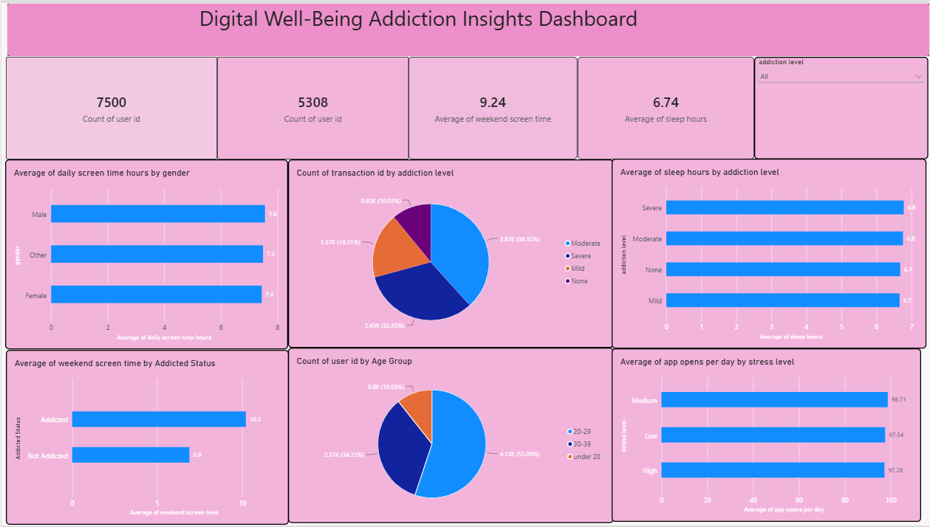

Key Insights:
- 7,500 total users were analyzed.
- 5,308 users (70.77%) are classified as addicted.
- Average daily screen time is approximately 7.50 hours.
- Average weekend screen time is approximately 9.24 hours.
- Average sleep time is approximately 6.74 hours.
- Average notifications are approximately 134 per day.
- Average app opens are approximately 98 per day.
6. Report
6.1. Report Design Screenshot with Insights
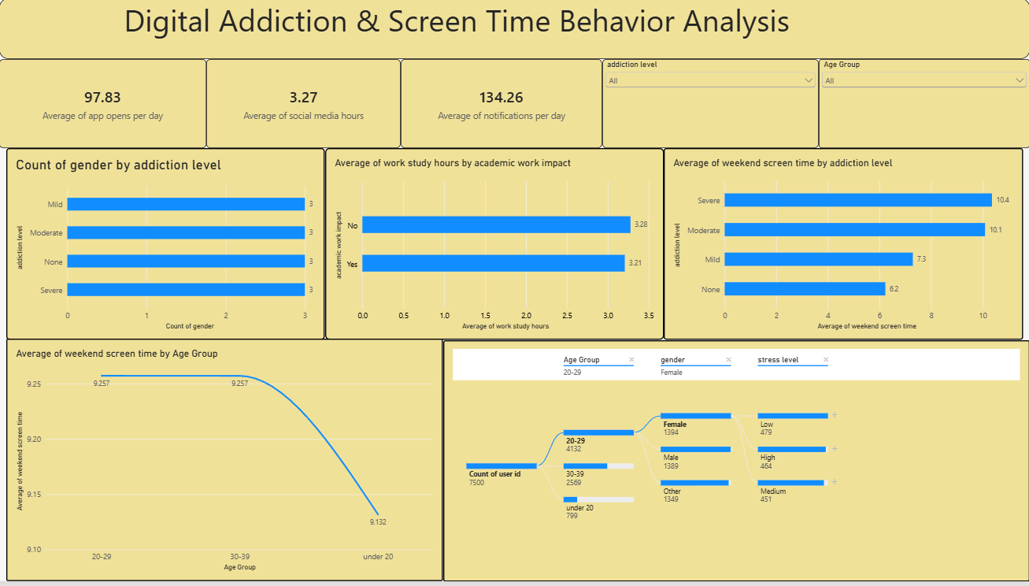
1. Addiction Severity:
Moderate and Severe users represent the largest groups among users with an assigned addiction level. Weekend screen time is particularly high for these groups, at approximately 10.09 hours for Moderate and 10.36 hours for Severe users.
2. Age, Sleep and Weekend Usage:
The 20–29 age group is the largest group in the dataset. Average sleep is approximately 6.74 hours, while weekend screen time is approximately 9.24 hours overall.
3. Engagement and Usage:
Users spend approximately 3.27 hours on social media, 2.01 hours gaming, and 3.24 hours on work/study per day. Users receive approximately 134 notifications and open apps approximately 98 times per day.
4. Stress and Academic/Work Impact:
Stress levels are relatively distributed across High, Medium, and Low categories. Average work/study time is approximately 3.28 hours for users without impact and 3.21 hours for users reporting impact.
7. Performance Testing
7.1 Utilization of Data filters
The dashboard provides interactive filters such as
- Age Group
  - Gender
- Addiction Level
- Stress Level
- Addicted Status
Academic/Work Impact
7.2 No of Calculation Columns/Measures
The Power BI report uses calculated fields,aggregations for metrics such as:
- User Count
- Addicted Status
- Age Group
- High Screen Time User
- Average Screen Time
- Average Sleep
- Average Weekend Screen Time
7.3 No of Visualization
The submitted Power BI file contains 5 report pages and 51 visual elements in total, including charts, KPI-style visuals, slicers, and analytical visuals.
8. Conclusion/Observation
The analysis of 7,500 users provides a detailed view of smartphone usage and digital addiction patterns. The dataset shows that 5,308 users (70.77%) are classified as addicted.
The Moderate addiction group contains 2,874 users, making it the largest defined addiction category. Weekend screen time is considerably high among Moderate and Severe users. Users also demonstrate high engagement through approximately 98 daily app openings and 134 daily notifications.
The average sleep duration of 6.74 hours and high smartphone engagement provide important areas for digital well-being analysis. The Power BI dashboard makes these patterns easier to explore through interactive filters and visualizations.
- Future Scope
- Develop personalized digital well-being recommendations based on individual smartphone usage patterns.
- Introduce screen-time limits, notification management, and app-usage reminders to reduce excessive usage.
- Add machine learning models to predict potential smartphone addiction risk.
- Extend the Power BI dashboard with real-time data monitoring and advanced analytics.
10. Appendix
10.1. Source Code(if any)
The project uses MySQL SQL queries for data cleaning, exploration, aggregation, and analysis. Power BI DAX measures are used to calculate KPIs and create dashboard visualizations.
10.2. GitHub & Project Demo Link
https://github.com/NarlaChaitanya63/Smartphone-Usage-Digital-Addiction-Well-Being-Analysis

